Dear Parents/Carers, 22.10.20

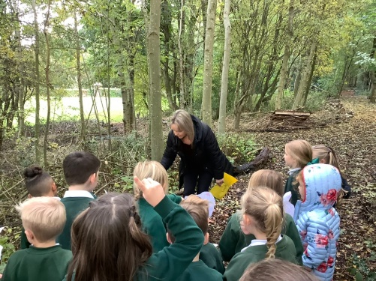
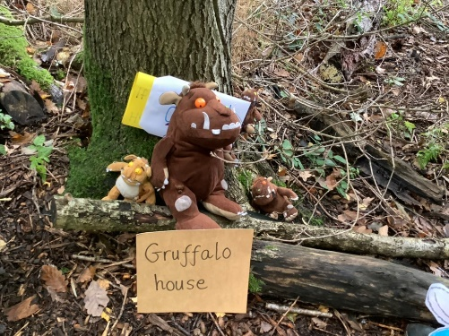
We have had a great few weeks in school, with the time flying by! I hope it has been a great few weeks for you and your children too! I cannot believe we are about to close for Half Term already! Although the half term has been very different in many ways, the learning and focus of the pupils has been very much celebrated along the way. We have been incredibly proud of the way the pupils have adapted to the changes in routines and the organisation of the learning in the classes. We are VERY pleased with the focus and progress the pupils have made since their return and look forward to having discussions with parents later in November. The pupils have shown great enjoyment in the range of learning experiences we have given so far (some pictures of the ‘Gruffalo walk’ in our school grounds for Class 1).
Following a half term of recovery learning and careful analysis of pupils needs, we will be sharing with you some of the additional support that we will be offering, to pupils who teachers feel will benefit, after the return to school in November. There are already a number of interventions taking place during the school day and we will be having further support opportunities at the end of the day for some pupils and classes moving forward – further details in the first week back.

Autumn Virtual Parent Consultations
We will be hosting the Autumn parent consultations in the next half term through a mixture of virtual meetings or telephone calls. This will give us the opportunity to discuss the transition back into school, the wellbeing, learning progress and attitude of your child so far this year – ensuring we work as partners to help them be the very best they can be.
Further information regarding the arrangements for the consultations will be sent out in the first week after half term. Each consultation will be 10 minutes only, as normal. We will be offering either a virtual meeting or a telephone call – we do need to remember however that there are only two telephones in school so this will need to be very carefully planned, the virtual meeting is certainly the preferred option wherever possible.

School Jotter APP:
If you have not already downloaded the school jotter app and signed in with the details sent by school, please make sure you do this over half term. This is a vital part of the communication methods from school – we are cutting down on paper communication.
The return of Class Mass in school
I am very happy to share with you, that we are once again able to celebrate Class Mass in the school hall with Father Eamonn. Unfortunately, we are not able to invite parents and family members to join us but it is a step in the right direction, I am sure you will agree. Class 6 are the first to welcome Father Eamonn who celebrated Mass this morning, for the pupils and staff in Class 6 only, along with myself and Mrs Nancy Morris, one of our Fondation Governors. Particpating in Mass is such an important part of our faith and as such having this opportunity once again within school is wonderful – thank you to Father Eamonn for his partnership working and support of the Catholic Life of our school.
Sacramental Preparation
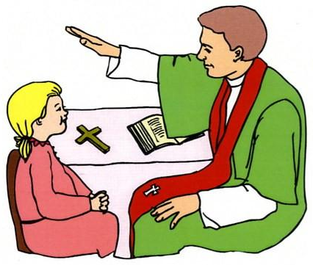
I am very happy to share with you all that the sacramental preparation, which had to be halted due to the pandemic and school closure, is due to begin again, although in a very different way after October half term. Please keep our current Class 4 and 5 pupils in your thoughts and prayers as they finish their preparations and receive the sacrament of Reconciliation, in school on Wednesday 18th November, and First Holy Communion in small groups leading up to Christmas.
Blessed Peter Snow Academy Trust
As you know our school will be converting to an academy sometime this school year and will become part of the Blessed Peter Snow Catholic Academy Trust. New parents/carers may want to have a look at the Academy Coversion page of the website, under the tab “Our School” which explains more about it.
We still do not have a date for conversion. The Trust is now waiting for the Academy Orders to be given for all school joining, including ours. Once this is received things will start to proceed and we will have more idea of the timeline ahead of us, but parents/carers and our pupils will not really notice any difference! You will notice the Trust logo as well as our own on letters and on the website after conversion – so here it is for you to see!
Half Term:
The pupils break up for half term today Thursday 22nd October returning on Monday 2th November. (The teachers have an INSET day tomorrow)
Thank you for your continued support and partnership working during this very different but believe very successful half term. Let us hope next half term is just as successful!
Kind Regards Mrs C Moulding (Head Teacher)

